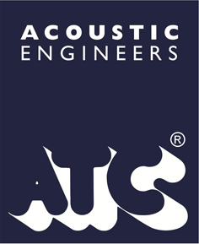

FOR IMMEDIATE RELEASE
16 March 2016, 3 pages.

SIGNATURE EDITION SCM10SE CELEBRATES A LIFE IN SOUND
ATC marks the 70th Birthday of its founder with the luxury edition of a favourite speaker…

ATC Loudspeaker Technology is celebrating the 70th birthday of its founder and Managing Director Billy Woodman with a ‘Signature’ version of a landmark ATC design. Based on the highly original and acclaimed SCM10 mini monitor from 1990, the Signature Edition SCM10SE is an immaculate reworking of the breakthrough model.
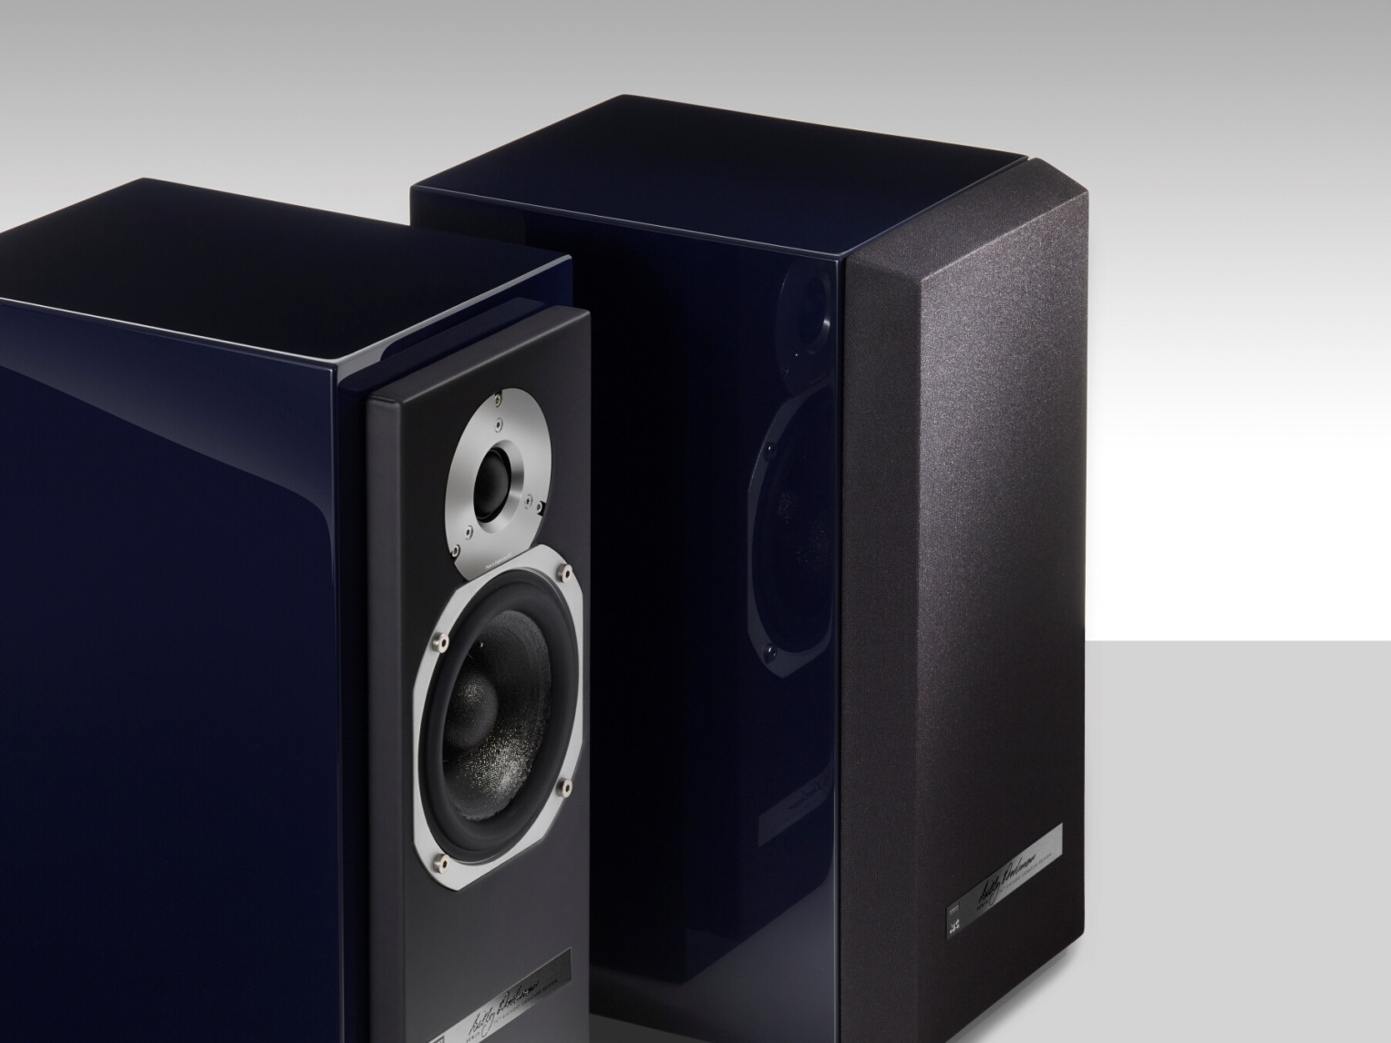
More…

Presented in a lustrous ATC blue piano finish, the SCM10SE is enhanced with an anodised silver aluminium tweeter wave guide, complementary silver mid/bass driver surround and a fine grain blue leather baffle, hand-finished by Eissmann, a leading supplier of pristine interior trims for many of the world’s most desirable car brands including Aston Martin, Bugatti, Lamborghini and McLaren.

Matching the flawless precision of its finish, the SCM10SE’s proprietary drivers and crossovers are wholly conceived and hand-built at ATC’s UK development and production facility in Stroud, Gloucestershire. The original SCM10’s soft dome tweeter has been replaced with a recently developed SH25-76S ‘S-Spec’ 25mm dual-suspension design, and its ground-breaking SB45-125SC 125mm mid/bass unit with a latest version, complete with integral soft dome. The system’s crossover is re-designed for the new drive units and uses ATC’s hand-wound air-cored inductors and high performance polypropylene capacitors throughout.

Appropriately the SCM10SE is limited to a production run of just seventy pairs, each supplied with an exclusive owner’s guide relating the story of Billy Woodman’s career from his formative engineering in Australia to the seminal, ethos-building work at Goodmans in the UK and culminating in the founding and flourishing of his Company as a world-renowned exponent of high performance audio reproduction systems for the studio, cinema, club and home.

Capturing the innovative spirit and uncompromising culture of ATC, the exclusive SCM10SE Signature speaker is a definitive 70th birthday tribute to the remarkable energy and influence of its founder, MD and Chief Engineer Billy Woodman.
Like all ATC products, the SCM10SE is backed by a six-year warranty.

Features

- New ATC designed and built ‘S’ specification 25mm Soft Dome HF unit with dual suspension, neodymium magnet assembly and a precision alloy wave guide.
- ATC 125mm short coil mid/bass unit with integral soft dome.
- In-house hand wound precision flat wire coil.
- Massive optimised motor assembly.
- Excellent impedance curve ensuring an easy load for any amplifier.
- Cabinet in exclusive ATC Blue high gloss piano finish.
- Baffle hand-bound in fine grain leather.
- 6 year warranty.
More…
Specification

Drivers HF: ATC SH25-76S 25mm Soft Dome; Bass/Mid: ATC SB45-125SC 125mm drive unit
Matched Response +/- 0.5dB
Frequency Response (-6dB) 50Hz–25kHz
Dispersion ±80° Coherent Horizontal, ±10° Coherent Vertical
Sensitivity 82dB @ 1W @ 1metre
Max SPL 103dB
Recommended Power Amplifier 75 to 300 Watts
Nominal Impedance 8 Ohm
Crossover Frequency 2.5kHz
Connectors Binding Posts/4mm Plugs, bi-wire
Cabinet Dimensions (HxWxD) 380x185x267mm
Weight 8kg

SCM10SE Price: Please contact your local authorised dealer or distributor for pricing in your region.

Availability: 23rd March 2016

CONTACTS FOR PUBLICATION: ATC, Gypsy Lane, Aston Down, Stroud, Gloucestershire GL6 8HR.
Tel: +44 (0)1285 760561
Email: info@atc.gb.net
www.atcloudspeakers.co.uk

ATC products are manufactured by Loudspeaker Technology Ltd, UK. ATC is a registered trademark of Loudspeaker Technology Ltd. Acoustic Transducer Company is a trading style of Loudspeaker Technology Ltd. All trademarks acknowledged

